MAD PROJECT

ROLLNO:21SW068

21SW131

21SW144

APPLICATION NAME : EduLearn App

1.PROBLEM STATEMENT:

Students often face challenges in finding quality educational content that suits their individual learning needs due to disorganized resources scattered across multiple platforms. Current platforms lack effective progress-tracking tools, which are crucial for monitoring achievements.. Additionally, students have restricted exposure to diverse subjects outside their academic focus. High costs of educational content further hinder access for lower-income learners, making quality education less accessible.

2.PROPOSED SOLUTION:

EduLearn is a mobile app designed to help students access and organize educational content effectively. It offers categorized courses in various fields like Development, Design, Data Science, and Business, enabling users to explore subjects aligned with their interests. The app enhances personalized learning by allowing students to track their progress through badges and milestones. EduLearn also features an explore option for discovering new courses and provides both free and affordable content, reducing financial barriers for students. Overall, the app centralizes learning materials and improves the learning experience by making quality education accessible anytime, anywhere. If there comes any conference for that it also enable user to get them know about that upcoming event.

3.Responsive User Interfaces:

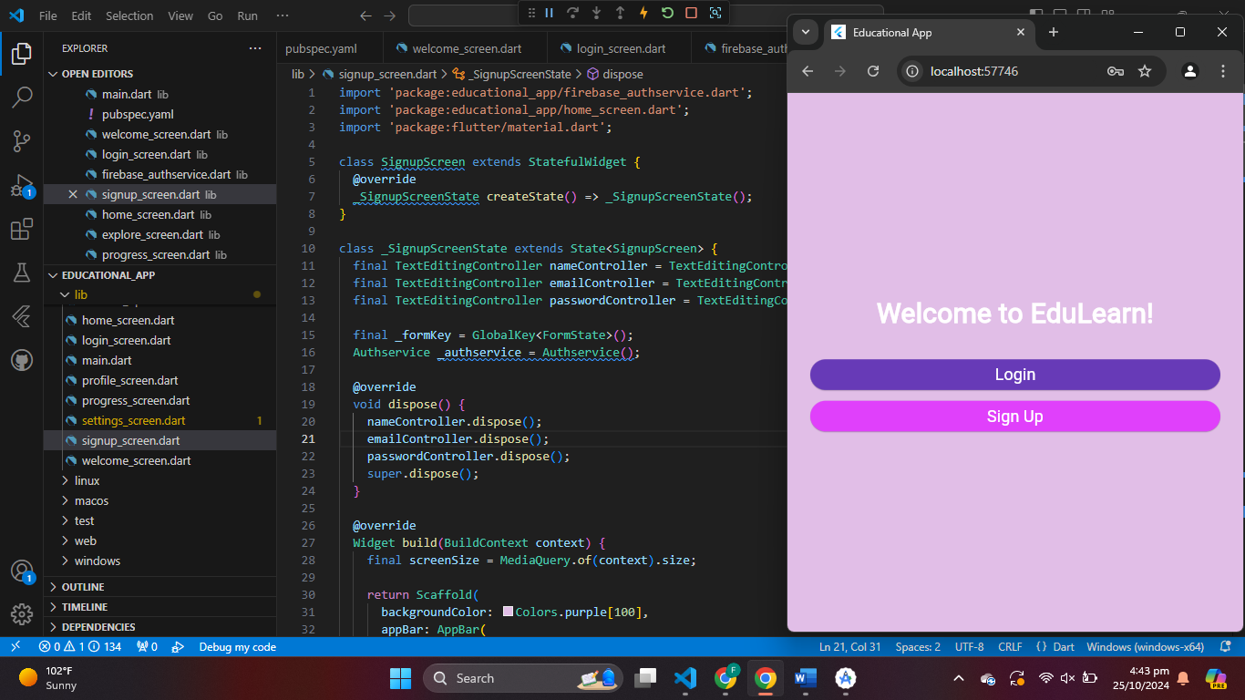

This screen shows the **Login** and **Sign Up** options on the app's welcome page, providing users with the ability to either log in to their existing account or create a new one.

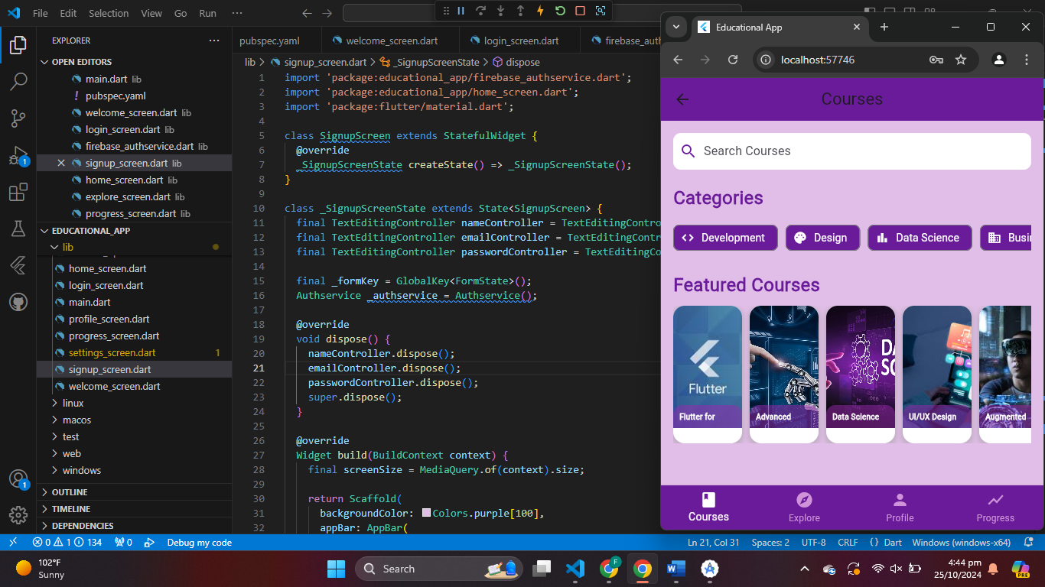

This screen shows the **Courses** page, where users can search for courses, browse different categories (Development, Design, Data Science, etc.), and view featured courses. The layout is adapted for easy navigation, displaying multiple categories and courses.

This screen shows the **Profile** page, displaying user details such as their name, number of courses completed, badges earned, XP points, and achievements. It provides a summary of the user’s progress in a structured format.

4.Data Storage:

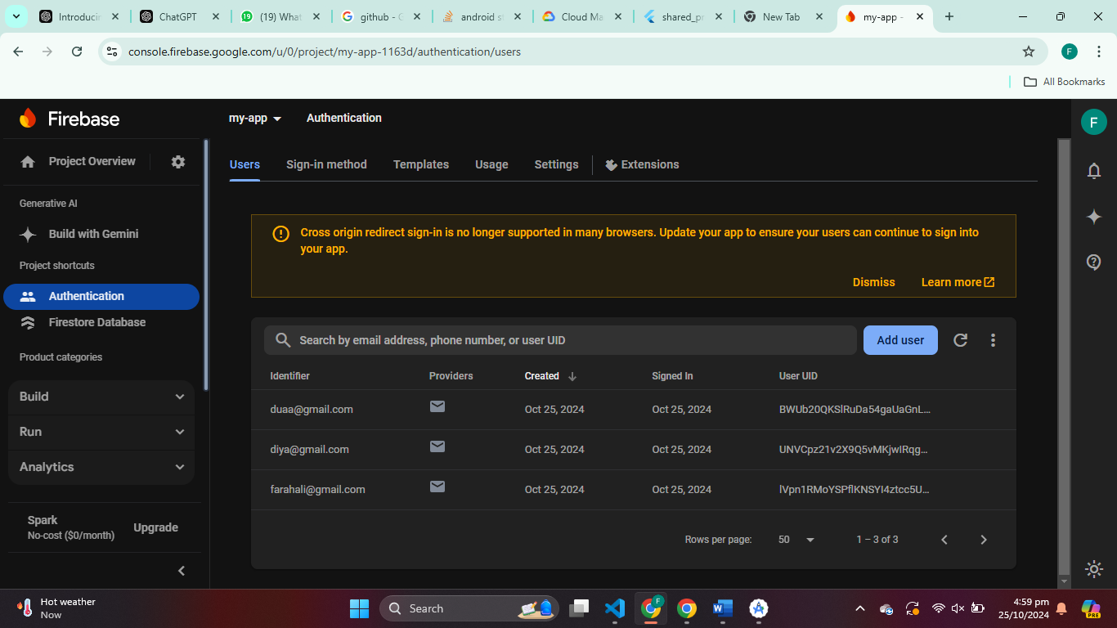

We chose Firebase as the database for EduLearn due to its scalability, real-time syncing capabilities, and seamless integration with mobile applications. Firebase also simplifies user account management with built-in authentication, were we have enable to store user emails and passwords.

We use Firestore for our data storage part where we added the courses that user clicked and wants to continue learning. keeping their learning experience consistent and uninterrupted. Its document-based NoSQL structure is flexible, enabling us to efficiently organize each user’s course data and progress while supporting millions of users as the app grows. Moreover, its integration with Firebase Authentication ensures that each user’s course data is stored securely and only accessible by authorized individuals, safeguarding user privacy

6.Issues and Bugs Encountered and Resolved during Development:

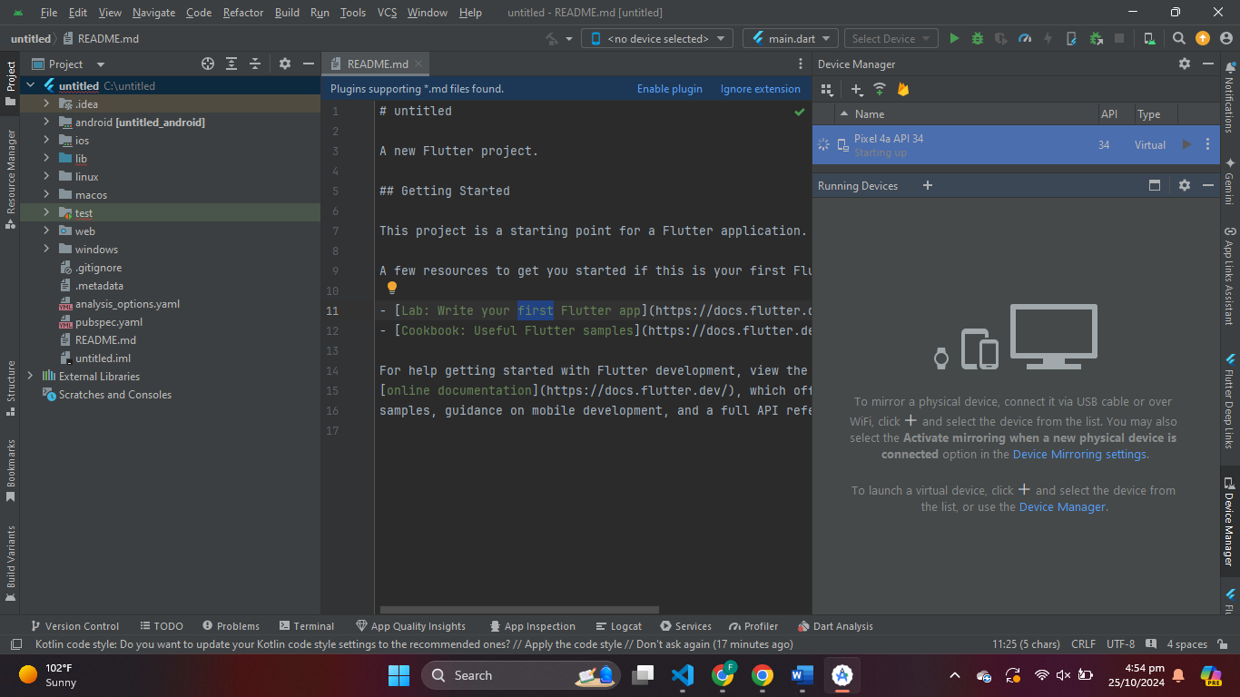

I faced an issue in Android Studio where the "Device Manager" pane overlapped with the code editor. To resolve this, I resized the panes by dragging the border and temporarily hid the "Device Manager" using the icon or Shift + Esc. For more space, I undocked the pane by right-clicking its title and selecting "Float." Lastly, I switched to a single tab layout by disabling "Side-by-Side Layout" under View > Appearance. These steps effectively resolved the issue.A computer screen shot of a program

I encountered an error while launching the Pixel 4a API 34 Android emulator in Visual Studio Code, which said, "Failed to launch Pixel 4a API 34: Error: Emulator didn’t connect within 6,576ms." To fix this, I checked the emulator settings, increased the timeout to 20 seconds, closed unnecessary programs, updated the Android Emulator, performed a cold boot, and enabled hardware acceleration in my BIOS. After these changes, I was able to successfully launch the emulator and run my Flutter app.